**Lung cancer using deep learning**

**ABSTRACT:** Lung disease is among the leading diseases that cause mortality worldwide. Most cases of lung diseases are detected when the disease is in the advanced stages. Therefore the development of systems and methods that enable faster and early diagnosis will play a vital role in the world today. Computer Aided Diagnosis (CADx) systems play such a role and are currently being expanded. This study explores the potential of using deep learning features from pre-trained deep learning architectures to provide rich and robust features. These features were compared to the conventionally used Gray-level Co-occurrence Matrix (GLCM). Deep features produced the highest accuracy of 100% as compared to 93.52% produced by using GLCM features. This study also compared the classification of deep features with five different classifiers and Support Vector Machine (SVM) showed the highest result. This high accuracy was also reproduced with Linear Discriminant Analysis (LDA) and Regression classifiers. Principal Component Analysis (PCA) was also done to evaluate the usage of reduced number of features and its effect on the classification performance. Using deep features produced 4096 features and a classification accuracy of 100%. When PCA is introduced, only 79 features were used however the accuracy produced was the same. Thus, there is promising use of deep features together with PCA to reduce the number of features in the classification of diseased lungs

**Keyword:** Medicinal, deep learning, Mobile net, CNN, minutiae

**Existing Method:**

In the existing there are methods implemented to classify lung disesase classification in deep learning. In method we are performing the classification medical plant identification using vgg16 of deep learning along with the Machine learning methods. As image analysis based approaches for classification of medical images.

**Disadvantages:**

• Less feature compatibility

• Low accuracy

**Proposed System:**

In purposed method we are performing the classification of either the image is medical plant identification using Mobile net and CNN of deep learning along with the Machine learning methods. As image analysis based approaches for medical plant classification and authentication. Hence, proper classification is important for the medical plant that which will be possible by using our proposed method. Block diagram of proposed method is shown below.

**Block Diagram:**

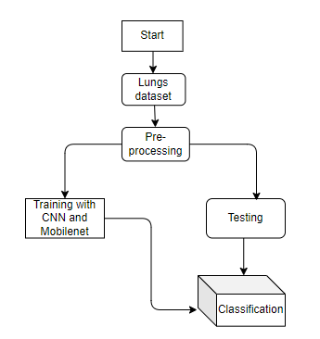

**Fig 1. Block diagram of proposed method**

**Advantages**:

* Accurate classification
* Less complexity
* High performance
* Easy Identification

**MODULES:**

**System**

**User**

**1. System:**

1.1 Create Dataset:

The dataset containing images of the Lung Cancer Classification i.e., normal are to be classified is split into training and testing dataset with the test size of 30-20%.

1.2 Pre-processing:

Resizing and reshaping the images into appropriate format to train our model.

1.3 Training:

Use the pre-processed training dataset is used to train our model using Mobile net and CNN Deep learning algorithm transfer learning methods.

1.4 Classification:

The results of our model are display of lungs images classification.

**2. User:**

2.1 Upload Image

The user has to upload an image which needs to be classified.

2.2 View Results

The classified image results are viewed by user.

**SYSTEM SPECIFICATIONS:**

# **H/W Specifications:**

# Processor : I5/Intel Processor

# RAM : 8GB (min)

* Hard Disk : 128 GB

**S/W Specifications:**

* Operating System : Windows 10
* Server-side Script : Python 3.6
* IDE : PyCharm,Jupyter notebook
* Libraries Used : Numpy, IO, OS, Flask, keras, pandas, tensorflow,OpenCV, pytesseract OCR

**LEARNING OUTCOMES:**

* Practical exposure to
  + - * Hardware and software tools
      * Solution providing for real time problems
      * Working with team/individual
      * Work on creative ideas
* Testing techniques
* Error correction mechanisms
* What type of technology versions is used?
* Working of Tensor Flow
* Implementation of Deep Learning techniques
* Working of CNN algorithm
* Working of Transfer Learning methods
* Building of model creations
* Scope of project
* Applications of the project
* About Python language
* About Deep Learning Frameworks
* Use of Data Science